**LAPORAN MINGGUAN PEMROGRAMAN 1**

**PRAKTIKUM ke 3**

**Nama : Aldi Reza Sastrawan**

**NPM : 4513210004**

1. **Program 401**

*Source-code*

import java.util.Scanner;

public class program401{

public static void main (String[]args){

int i;

for(i=0; i<10; i++)

{

System.out.println("Belajar java "+i);

}

}

}

*Screen-shot*

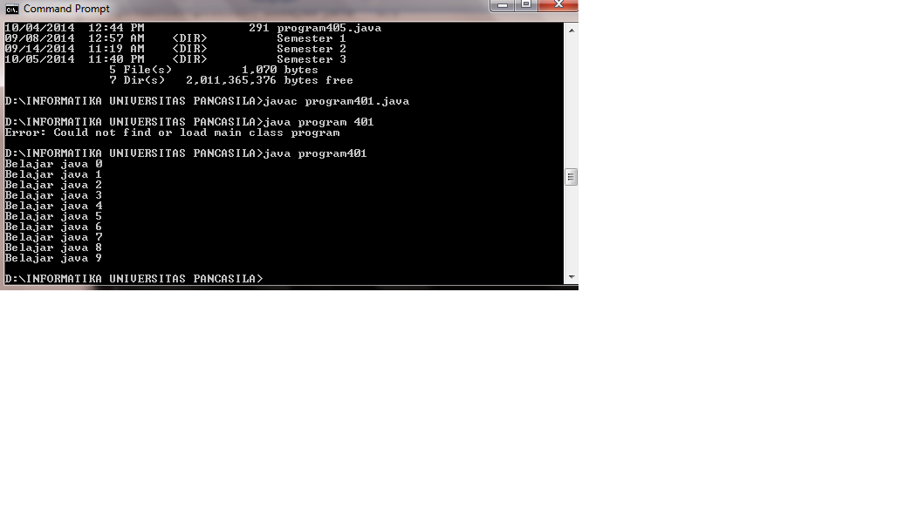

**2. Program402**

*Source-code*

import java.util.Scanner;

public class program402{

public static void main (String[]args){

int i;

for(i=0; i<20; i+=2){

System.out.println("i= "+i);

}

}

}

*Screen-shot*

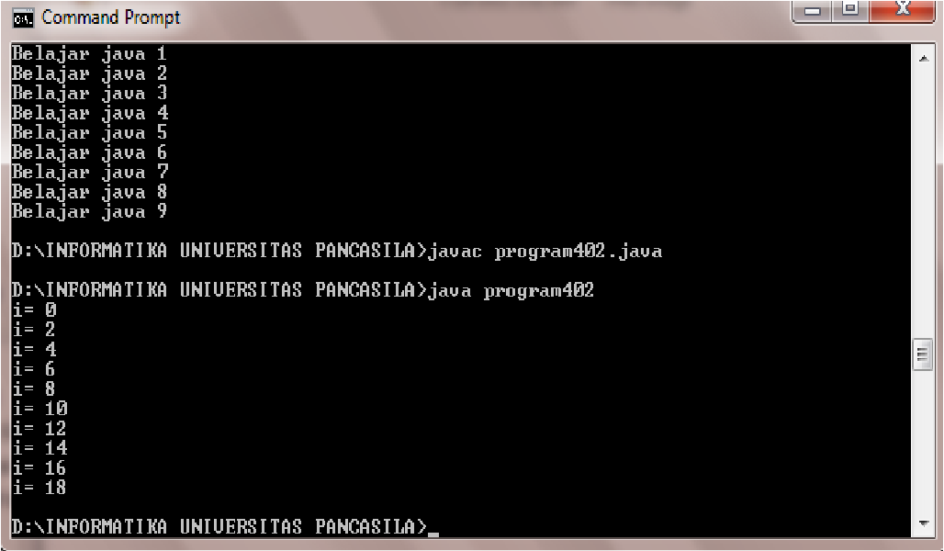

**3. Program403**

*Source-code*

import java.util.Scanner;

public class program403{

public static void main (String[]args){

int i;

for(i=13; i<=100; i++)

{

if (i % 2 ==0)

{

System.out.println(i);

}

}

}

}

*Screen-shot*

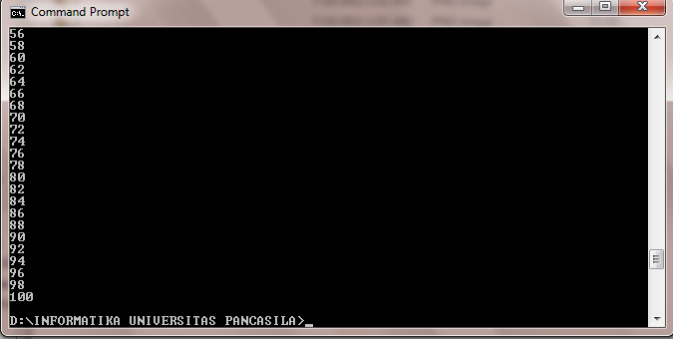

**4. Program404**

*Source-code*

import java.util.Scanner;

public class program404{

public static void main (String[]args){

int i,jumlah;

jumlah=0;

for (i=0; i<=10; i++){

jumlah=jumlah + i;

System.out.println (jumlah);

}

}

}

*Screen-shot*

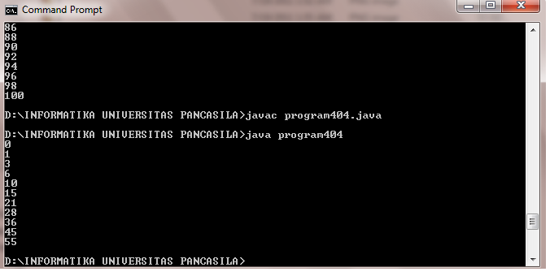

**5. Program405**

*Source-code*

public class program405{

public static void main (String[] args){

int i,jumlah;

jumlah=0;

System.out.println(" ");

for(i=0; i<10; i++){

jumlah=jumlah +i;

if(jumlah%2!=0) {System.out.println("jumlah");}

else {

System.out.println(jumlah);

}

}

}

}

*Screen-shot*

